**Experiment 4**

**Aim –** Create a class to find out the Area and perimeter of a Rectangle

**Theory–**

**Program :**

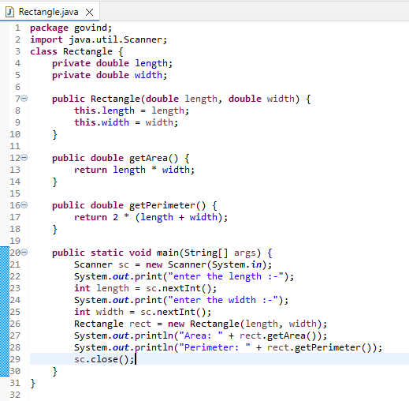

**package** govind;

**import** java.util.Scanner;

**class** Rectangle {

**private** **double** length;

**private** **double** width;

**public** Rectangle(**double** length, **double** width) {

**this**.length = length;

**this**.width = width;

}

**public** **double** getArea() {

**return** length * width;

}

**public** **double** getPerimeter() {

**return** 2 * (length + width);

}

**public** **static** **void** main(String[] args) {

Scanner sc = **new** Scanner(System.***in***);

System.***out***.print("enter the length :-");

**int** length = sc.nextInt();

System.***out***.print("enter the width :-");

**int** width = sc.nextInt();

Rectangle rect = **new** Rectangle(length, width);

System.***out***.println("Area: " + rect.getArea());

System.***out***.println("Perimeter: " + rect.getPerimeter());

sc.close();

}

}

**Output:**

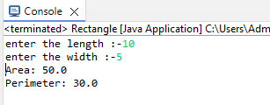

**Learning Outcome:**